**Basic Programming Practicum Assignment Jobsheet 4**



**From:**

AL AZHAR RIZQI RIFA’I FIRDAUS

**Class:**

1 I

**Absence:**

01

**Major:**

Information Technology

**Study Program:**

Informatic Engineering

Assignment

1. Create a program to input two integers, then print the one with the largest value!

2. Observe the following flowchart!

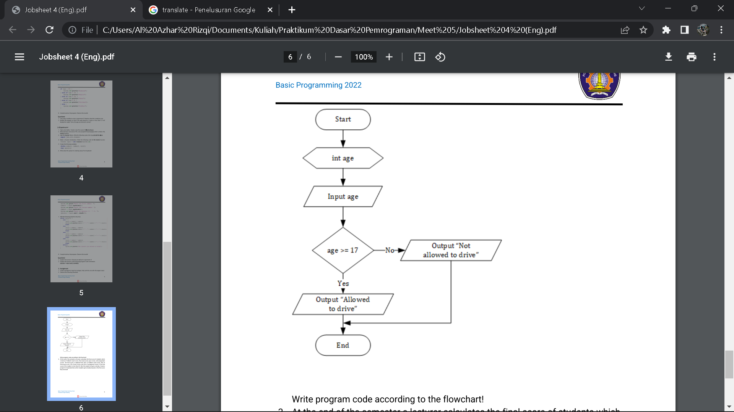

Write program code according to the flowchart!

3. At the end of the semester a lecturer calculates the final score of studentswhichconsists of midterm exam score, final exam score, quiz scores, and assignmentscores. The final score is obtained from 30% of midtermexamscore, 40%offinal exam score, 10% of quiz scores, and 20% of assignment scores. If thefinal score of the student is less than 65, then the student will get a remedy. Createaprogram to help determine which students get remedies based on the final scorethey received!

Answer

1. Code :

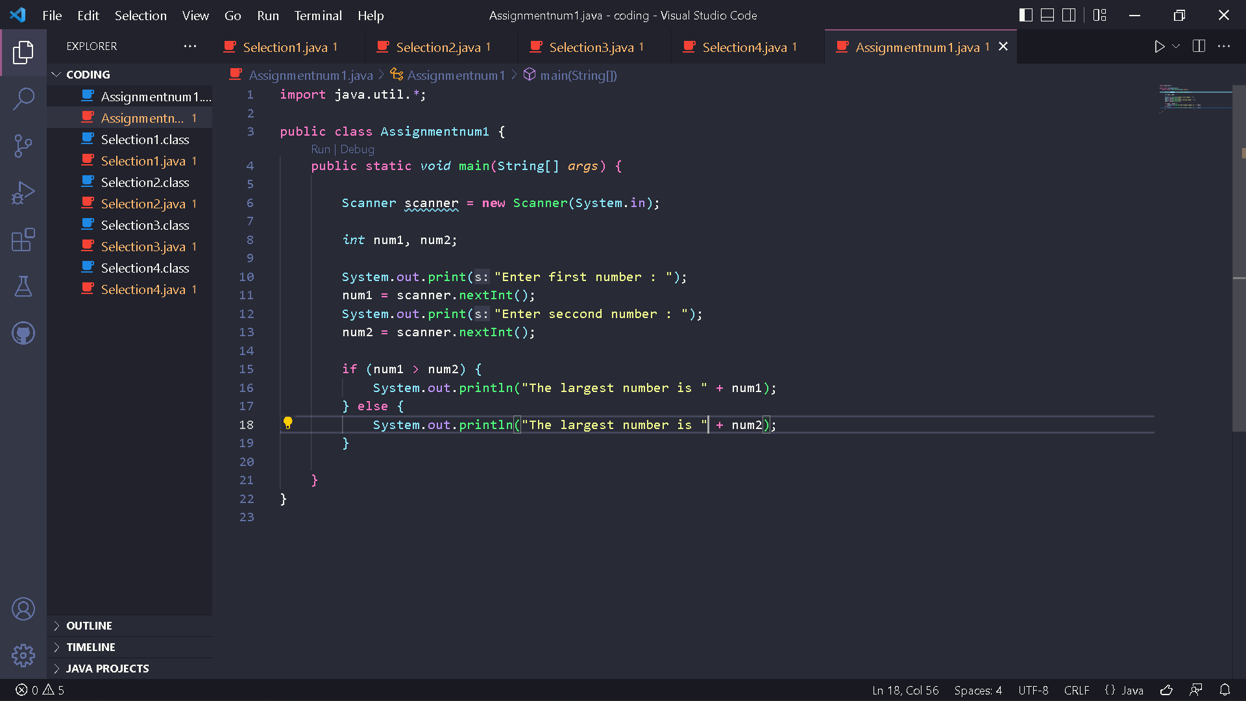

Result :

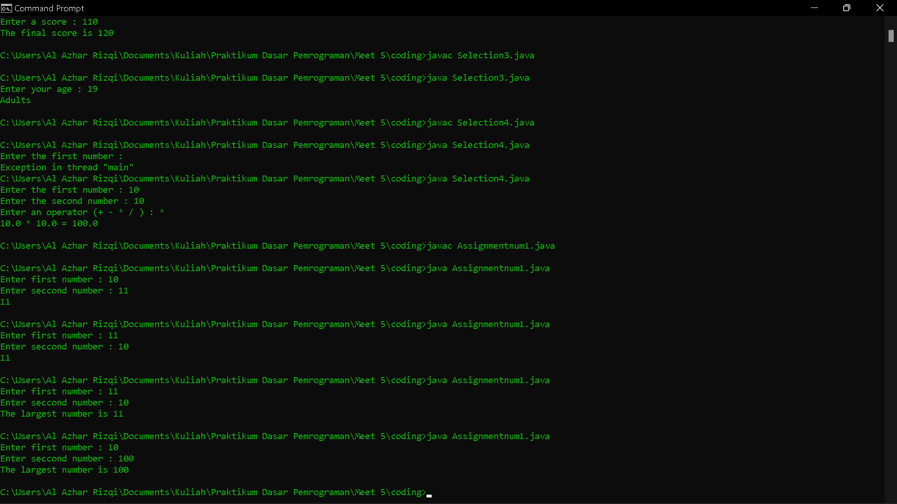

1. Code :

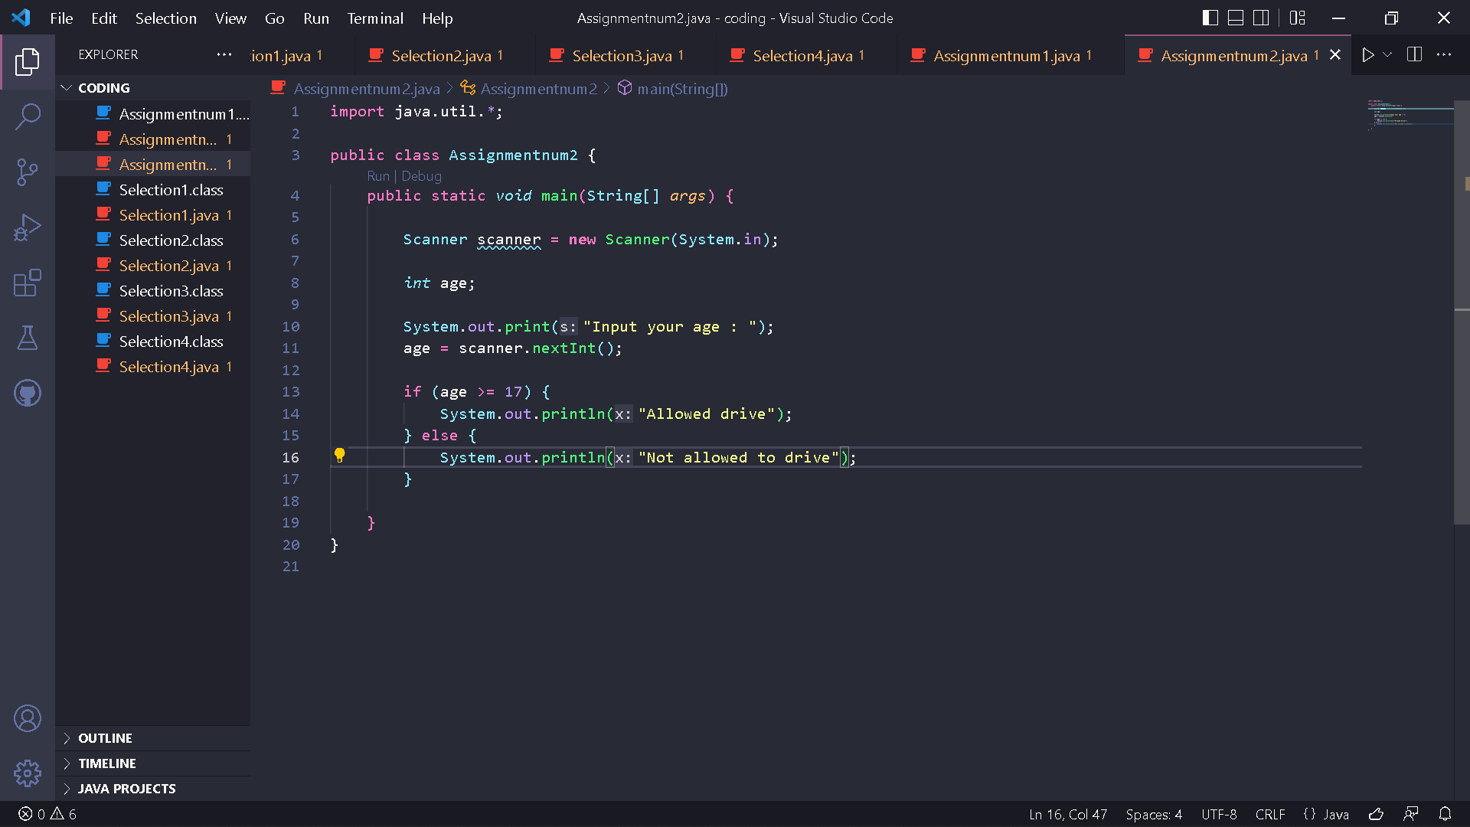

Result :

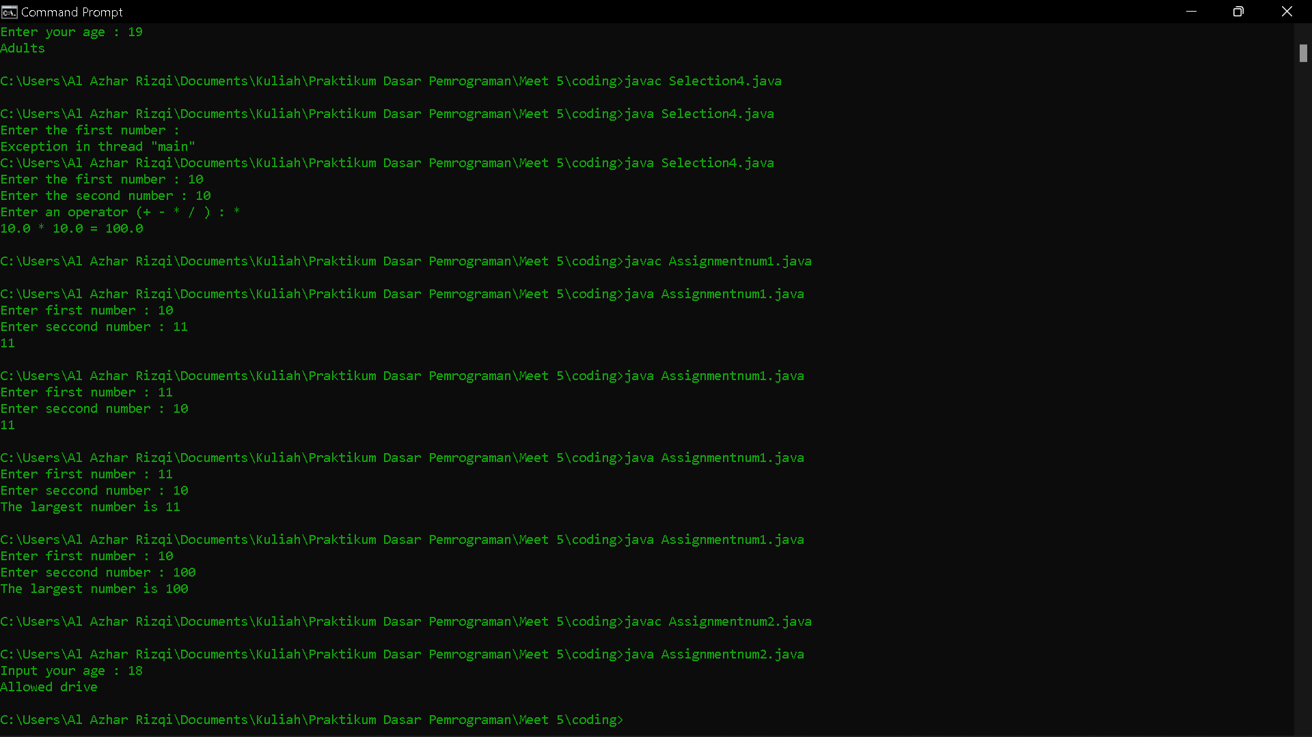

1. Code :

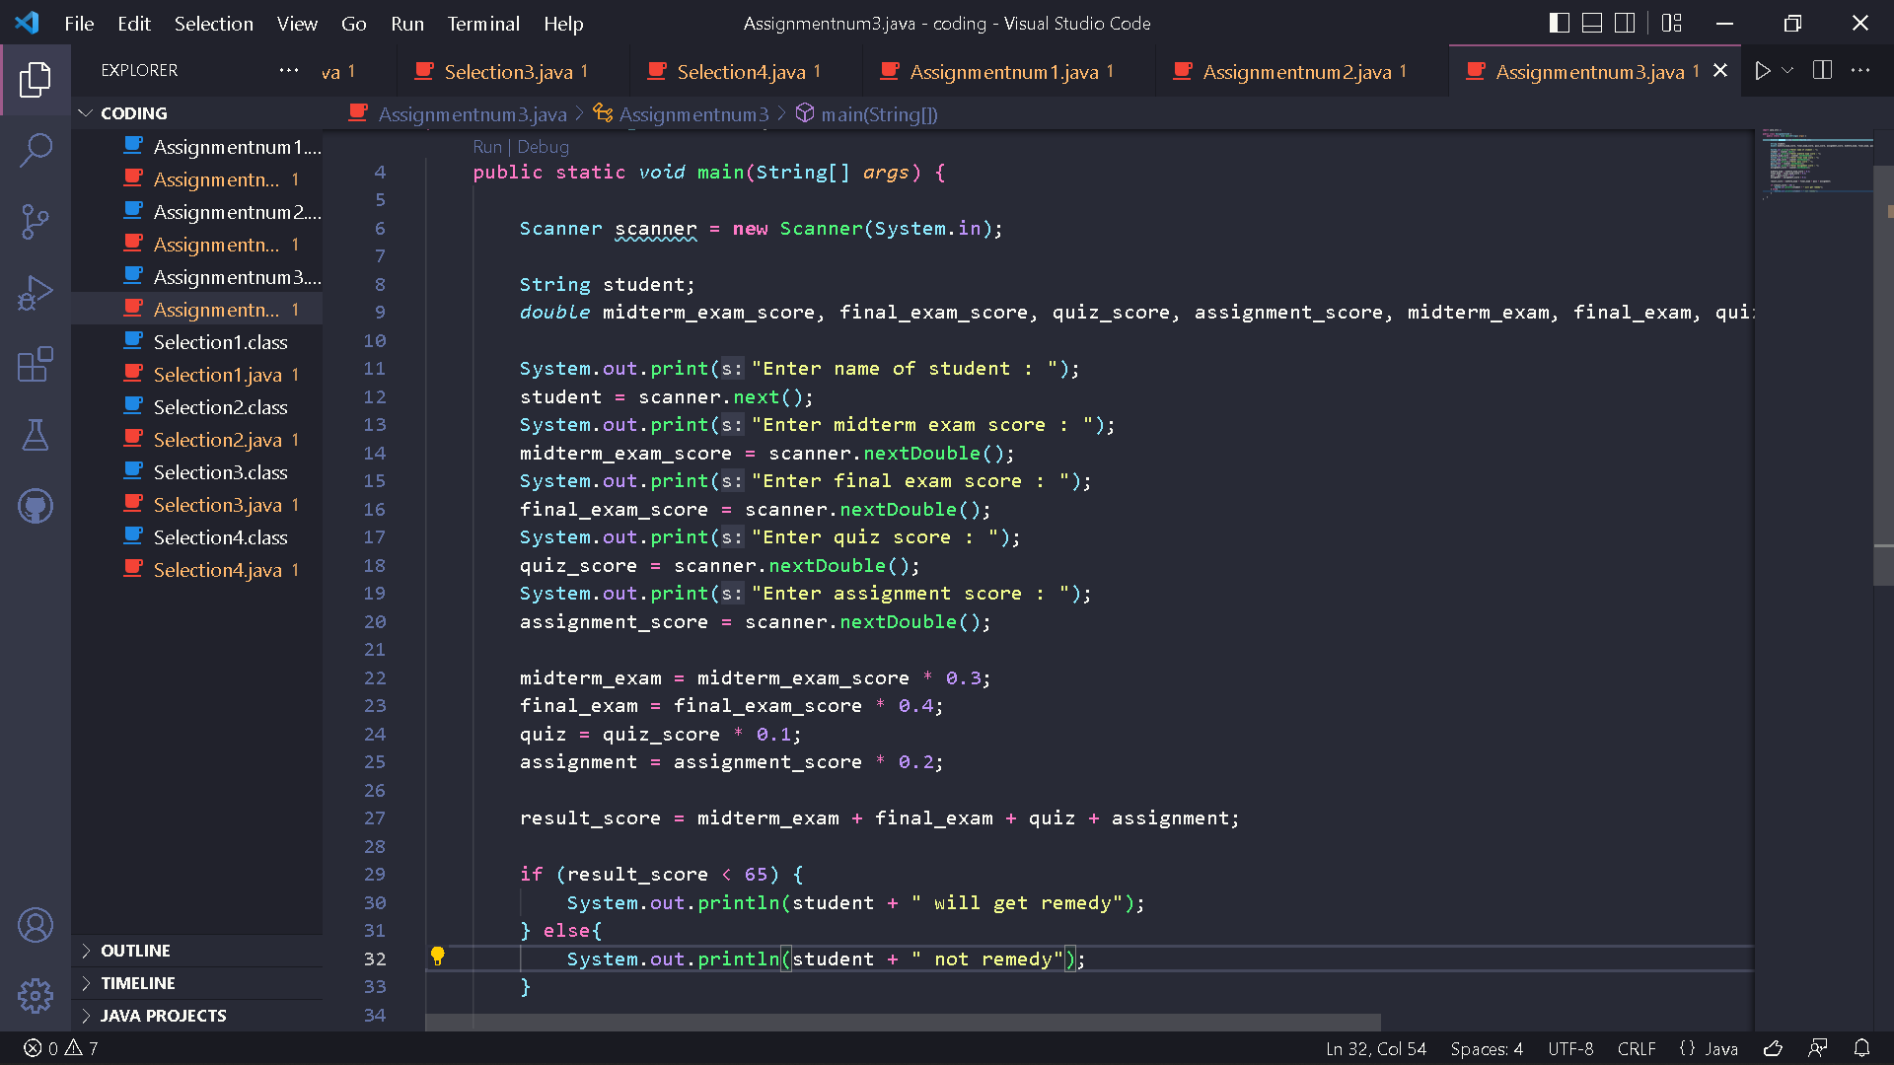

Result :

